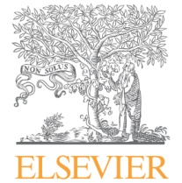
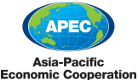

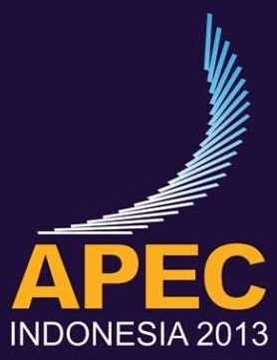

APEC SCIENCE PRIZE for INNOVATION, RESEARCH and EDUCATION (ASPIRE)

OVERVIEW

The APEC Science Prize for Innovation, Research and Education (“ASPIRE”) is an annual award to recognize young scientists who have demonstrated a commitment to both excellence in scientific research, as evidenced by scholarly publication, and cooperation with scientists from other APEC member economies.

The ASPIRE Prize supports APEC’s mission to:
- strengthen international science and technology networks;
- enhance economic growth, trade and investment opportunities in harmony with sustainable development, through policies, innovative R&D and technologies, and knowledge sharing; and
- improve linkages and efficiency between research and innovation.

ASPIRE 2013 NOMINATION THEME

Each year the APEC host economy is asked to provide a theme to guide nominations for the ASPIRE Prize to be awarded in their host year. For its host year of 2013 Indonesia selects “SUSTAINABLE OCEAN DEVELOPMENT” as the ASPIRE theme, building on its desire that APEC actively promote environmentally and economically sustainable solutions for oceans and waterways.

Each member economy, through its representative on the APEC Policy Partnership for Science, Technology and Innovation (PPSTI), is invited to nominate one young scientist under the age of 40 to be considered for the 2013 ASPIRE Prize. Nominees should demonstrate excellence in scientific research, as evidenced by scholarly publication, and cooperation with scientists from other APEC member economies in subjects such as: oceanography and marine sciences; aquaculture and fisheries science; hydrology; hydrography; coastal geography; environmental science and ecology, among others.

ELIGIBILITY

Any citizen of an APEC member economy is eligible to be nominated for the ASPIRE Prize. He/she must be living at the time of his/her nomination and be under the age of 40 as of 31 December of that year (i.e., all 2013 nominees must be under the age of 40 as of 31 December 2013).

SELECTION PROCESS

Each member economy, through its representative on the APEC Policy Partnership for Science, Technology and Innovation (PPSTI), will nominate one young scientist under the age of 40 by 3 May 2013 to be considered for the 2013 ASPIRE Prize.

Once nominations are received PPSTI members rank the nominees through a selection ballot to determine the winner. PPSTI members are asked to judge the nominees based on how well they have demonstrated:
- excellence in scientific research, as evidenced through scholarly publication;
- commitment to cooperation with scientists from other APEC member economies; and
- contribution to the theme selected by that year’s host economy.

ASPIRE PRIZE SPONSORS

Wiley and Elsevier, two of the world’s leading publishers of scholarly scientific knowledge, have committed to funding prize money in the amount of $25,000 USD.

PREVIOUS ASPIRE PRIZE CEREMONIES

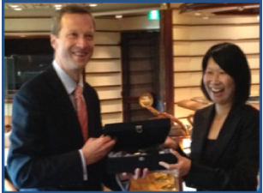
Dr. Rossa Wai Kwun Chiu of Hong Kong, China was awarded the 2012 ASPIRE Prize and recognized for her accomplishments at the APEC Ministerial Meeting in Vladivostok, Russia.

Russia selected health innovation as its ASPIRE nominating theme, building on its desire that APEC actively foster cooperation among economies in major innovation areas, such as human health, to support healthy lifestyles, productivity and economic growth. Dr. Chiu’s groundbreaking research and innovations in chemical pathology has brought non-invasive prenatal diagnosis of fetal genetic diseases into routine clinical use around the world.

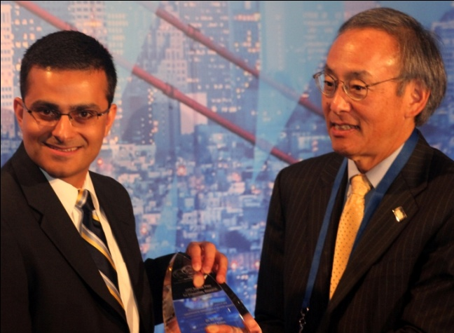
In 2011 the ASPIRE Prize was awarded by Nobel Laureate and U.S. Secretary of Energy Steven Chu to Dr. Ali Javey of the United States on the margins of the APEC Joint Transportation and Energy Ministerial Conference, held 13 September in San Francisco, United States.

The United States selected green growth as its ASPIRE nominating theme, building on its desire that APEC actively promote environmentally sustainable economic growth and development, and help our economies successfully transition to a clean energy future.

Dr. Javey’s innovative work with nanomaterials has made great strides in developing a new generation of solar energy technology and reducing energy consumption in “green electronics.”

ENCLOSURES

Within this packet you will find:

- ASPIRE 2013 Local Nomination Form

- For Reference:
  - APEC Secretariat press release: Winner of 2012 ASPIRE Prize for health innovation announced
(http://www.apec.org/Press/Features/2012/0907_aspire.aspx)
  - APEC Secretariat press release: U.S. Energy Secretary Chu announces APEC ASPIRE prize winner (http://www.apec.org/Press/News-Releases/2011/0913_aspire.aspx)
  - APEC Secretariat press release: APEC launches ASPIRE prize for innovative scientists (http://www.apec.org/Press/News-Releases/2011/0727_scientist.aspx)

2013 APEC Science Prize for
Innovation, Research and Education

LOCAL NOMINATION FORM

YOUR APEC ECONOMY: [INSERT BEFORE SUBMISSION]

LOCAL ECONOMY DEADLINE: Please inquire with the PPSTI Program Director (Mr. Mikiharu SHIMIZU @ miki@apec.org) and PPSTI Program Executive (Ms. Linnus Teo Siow Yen @ ltsy@apec.org) AS SOON AS POSSIBLE. ALL APEC economies have been asked to submit their one nominee for consideration by 3 May 2013. Their local deadlines will be prior to that date.

APEC MEMBER ECONOMIES INCLUDE: Australia, Brunei Darussalam, Canada, Chile, China, Hong Kong, Indonesia, Japan, Korea, Malaysia, Mexico, New Zealand, Papua New Guinea, Peru, Philippines, Russia, Singapore, Chinese Taipei, Thailand, United States, Vietnam

APEC SCIENCE PRIZE for INNOVATION, RESEARCH and EDUCATION (ASPIRE)

ASPIRE 2013 LOCAL NOMINATION FORM (Page 1 of 3)

Thank you for your interest in being selected to represent your APEC economy for the 2013 ASPIRE Prize. Please submit this form and the required documents to the PPSTI Program Director (Mr. Mikiharu SHIMIZU @ miki@apec.org) and PPSTI Program Executive (Ms. Linnus Teo Siow Yen @ ltsy@apec.org) so they may direct them to your local economy representative for consideration. Interested candidates are encouraged to contact the PPSTI Program Executive AS SOON AS POSSIBLE to determine the submission deadline for consideration by their local economy representatives. All APEC economies have been asked to submit their one nominee for consideration by 3 May 2013. Local deadlines will therefore be in advance of 3 May 2013.

INSTRUCTIONS: Please complete the fields below. The Nomination Statement should consist of up to 300 words describing how the nominee has demonstrated: excellence in scientific research, as evidenced through scholarly publication; commitment to cooperation with scientists from other APEC member economies; and contribution to the year’s selected theme.

For its host year of 2013 Indonesia selects “SUSTAINABLE OCEAN DEVELOPMENT” as its theme, building on its desire that APEC actively promote environmentally and economically sustainable solutions for oceans and waterways. Nominations are therefore sought from young scientists under the age of 40 in subjects such as: oceanography and marine sciences; aquaculture, fisheries and fish science; hydrology; hydrography; coastal geography; environmental science and ecology, among others.

Please list the scientist’s publications in the appropriate field (publication titles should be translated into English). The nominee’s record of scholarly publication will be evaluated on its merits, and candidates are encouraged to include publications regardless of the publisher. A Curriculum Vitae and at least one letter of recommendation should also be attached for consideration.

Nomination Statement (up to 300 words)

ASPIRE 2013 LOCAL NOMINATION FORM (Page 2 of 3)

Nominee Information
Member Economy:
Last Name: | First Name:
Date of Birth (day/month/year):
Address:
Telephone: | Email:
Title:
Institution/Affiliation:
Field of Research:
Total Scholarly Publications: ____

Total Citations: ____

Hirsch Factor (h-index): ____
The Hirsch factor or h-index attempts to measure both the productivity and impact of the published work of a scientist or scholar. The index is based on the set of the scientist’s most cited papers and the number of citations that they have received in other publications.

Total publications that include co-authors from APEC member economies: ____
APEC member economies include: Australia, Brunei Darussalam, Canada, Chile, People’s Republic of China, Chinese Taipei, Hong Kong, Indonesia, Japan, Republic of Korea, Malaysia, Mexico, New Zealand, Papua New Guinea, Peru, Philippines, Russia, Singapore, Thailand, United States, and Vietnam.
List of Scholarly Publications (Please list below in English):

Please denote which scholarly publications include co-authors from APEC member economies, for example:
1. A.S. Barnard, H. Konishi, H. Xu, ‘Morphology mapping of platinum catalysts over the entire nanoscale’, Catal. Sci. & Tech. (2011) accepted [APEC Authors]
2. H. Guo, A.S. Barnard, ‘Computational challenges in accurate modeling of iron oxides and oxyhydroxides, and the prediction of environmentally sensitive phase transformations’, Phys. Rev. B, 83 (2011) 094112
3. L.Y. Chang, E. Osawa, A.S. Barnard, ‘Confirmation of the electrostatic self-assembly of nanodiamonds’, Nanoscale, 3 (2011) 958 [APEC Authors]

Other Awards/Achievements (Please list below in English):

Please denote which, if applicable, have a connection to other APEC member economies.

ASPIRE 2013 NOMINATION FORM (Page 3 of 3)

Nominator Information
Member Economy:
Last Name: | First Name:
Telephone: | Email:
Relation to Candidate (if any):
Title:
Institution/Affiliation:
Nominator Signature (typed):

Remember to include copies of the candidate’s Curriculum Vitae, and at least one letter of recommendation. These may be submitted electronically along with this Nomination Form.

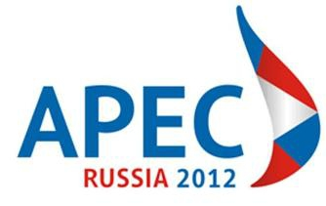

APEC SCIENCE PRIZE for INNOVATION, RESEARCH and EDUCATION (ASPIRE)

APEC SECRETARIAT PRESS RELEASE: Winner of 2012 ASPIRE Prize for health innovation announced

http://www.apec.org/Press/Features/2012/0907_aspire.aspx

Winner of 2012 ASPIRE Prize for health innovation announced

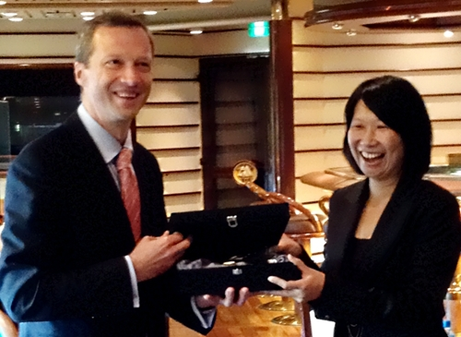

Dr. Rossa Wai Kwun Chiu was presented the APEC Science Prize for Innovation, Research and Education (ASPIRE) Prize on Thursday by Dr. Sergey Ivanets, President of Far Eastern Federal University, alongside the APEC Economic Leaders’ Week in Vladivostok, Russia.

“Health innovation,” the theme for this year’s ASPIRE Prize, was chosen to foster cooperation among economies to support healthy lifestyles, productivity and economic growth. The ASPIRE Prize carries a USD 25,000 award.

Dr. Chiu, who is a chemical pathology professor at the Chinese University of Hong Kong’s Morningside College and from Hong Kong, China, was selected as the winner of the ASPIRE Prize for her research and development of non-invasive prenatal diagnostic approaches which demonstrated excellence in scientific research, evidenced by scholarly publication, and cooperation with scientists from other APEC member economies.

Honoring Dr. Chiu on Thursday, Dr. Ivanets said that the ASPIRE Prize recognizes the vital importance of cross-border scientific and technological cooperation in the world’s fastest growing region.

“Dr. Chiu embodies the cross-border collaboration that is so vital to advancing the future discoveries that will drive our economies and the health of our citizens.” said Ivanets.

Dr. Chiu successfully used next-generation DNA sequencing in DNA plasma of pregnant women for non-invasive prenatal diagnosis of Down syndrome and performed large-scale clinical studies to validate the test. The clinical use of non-invasive testing for Down syndrome detection is now routine in Hong Kong and the United States, based on her findings.

“Collective efforts between researchers allow resources to be used efficiently for the maximal impact of research,” said Dr. Chiu, who collaborated with scientists from China, Malaysia, Singapore, Thailand and the United States to advance her research.

“Cooperation enables the rapid dissemination and application of the fruits of research, translating into tangible benefits for citizens across the region.”

Dr. Chiu has produced 105 papers in international peer-reviewed journals, including Prenatal Diagnosis, Science, The Lancet, The Journal of Pathology, Hematology/Oncology Clinics of North America, Blood, and Seminars in Fetal & Neonatal Medicine, among others.

On winning the ASPIRE prize, Chiu said, “I sincerely hope that the work of my research group on non-invasive prenatal diagnosis would save the fetuses whom would potentially be lost due to the conventional prenatal diagnostic procedures.”

ISTWG Lead Shepherd Dr. Nares Damrongchai lauded Dr. Chiu’s research and the contributions of the other ASPIRE nominees. “APEC continues to lead the way in promoting the vital role of health innovation and collaboration in sustaining the region’s economic growth,” he said.

“The scientific advances of the region’s world-class researchers are very significant and playing a critical role in addressing key health challenges.”

Ambassador Muhamad Noor, Executive Director of the APEC Secretariat, said that the ASPIRE prize encourages work and research by young scientists.

“APEC recognizes innovations in health as crucial for productivity and economic growth for our member economies,” said Noor. “The ASPIRE Prize is indicative of APEC economies’ commitment to promoting research and development that improves the quality of people’s lives and economic productivity in the region.”
The 2012 ASPIRE Prize is sponsored by John Wiley & Sons, Inc., and Elsevier, two of the world’s leading publishers of scholarly scientific knowledge.

# # #
For more information, contact: media@apec.org



APEC SCIENCE PRIZE for INNOVATION, RESEARCH and EDUCATION (ASPIRE)

APEC SECRETARIAT PRESS RELEASE: U.S. Energy Secretary Chu announces APEC ASPIRE prize winner

http://www.apec.org/Press/News-Releases/2011/0913_aspire.aspx

U.S. Energy Secretary Chu announces APEC ASPIRE prize winner
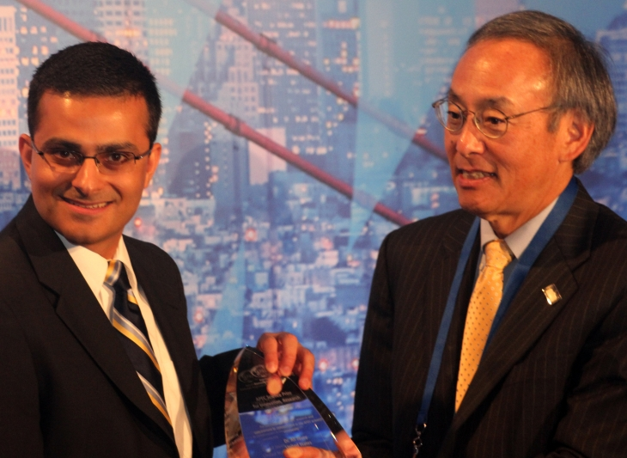
U.S. Secretary of Energy Steven Chu announced today the winner of the inaugural APEC Science Prize for Innovation, Research and Education (ASPIRE Prize) on the sidelines of the APEC Transportation and Energy Ministerial Conference in San Francisco.
Winning the prize for his innovative research on how nanomaterials drive a new generation of solar energy technology Dr. Ali Javey, an Associate Professor at the University of California, Berkeley and the Co-Director of the Berkeley Sensor and Actuator Center, was recognized for his research commitment to both excellence in scientific research, as evidenced by scholarly publication, and cooperation with scientists from other APEC member economies.
When he awarded the US$ 25,000 prize to Javey, U.S. Secretary Chu praised the winner for his collaboration with scientists across the APEC region.
"Dr. Javey's research and the research of his fellow ASPIRE nominees have the power to unlock science in ways that will propel our economies,” said Secretary Chu. “This is science that can and will help to solve our shared challenges."
Dr. Javey was selected from among a pool of 11 contenders by the APEC Industrial Science and Technology Working Group (ISTWG). The Lead Shepherd of the ISTWG, Madam Wan Zaharah Wan Mohamad, noted that the economies nominated “exceptional and high potential candidates” whose specialization ranged from nanotechnology to nuclear safety.
“The selection committee was very impressed with Dr. Ali Javey’s cutting edge research in green electronics. He is an example of a highly accomplished young researcher,” Wan Zaharah said in a written statement. “All the nominees are winners for their economies and for the APEC region as each have its own merits and significant contributions to science.”
Ambassador Muhamed Noor, Executive Director of the APEC Secretariat, expressed hope that the ASPIRE Prize will continue to encourage young scientists to conduct world-class research in the region.
“The ASPIRE prize demonstrates APEC’s commitment to supporting research and development in the region and we also recognize that science and technology is an integral component for economic development,” said Noor as he offered his congratulations to Dr. Javey.
Dr. Javey is the first recipient of the ASPIRE Prize. “In receiving this prize I have to acknowledge the talented scientists I have the privilege of working with around the world and, in particular, in the APEC region,” he said. “It is by working together that we are able to do the most exciting scientific research."
Dr. Ali Javey is an Associate Professor at the University of California, Berkeley and the Co-Director of the Berkeley Sensor and Actuator Center. He has developed low-cost, flexible, and lightweight photovoltaic cells that can achieve a theoretical efficiency of 20 percent or more and can be easily rolled onto roofs and other surfaces. Dr. Javey has also developed transistor arrays that use a fraction of the power of conventional silicon transistors. He has produced 81 publications with over 5,000 citations in peer-reviewed journals including Nature, Advanced Materials, and the Journal of the American Chemical Society.
More information on the other nominees can be found at http://www.apec.org/aspire2011. The ASPIRE Prize is sponsored by John Wiley & Sons, Inc. and Elsevier.
# # #
For more information, contact: Ai Ghee Ong at +65 6891 9671 or oag@apec.org or Michael Chapnick + 65 6891 9670 or mc@apec.org
For more information, contact: media@apec.org

APEC SCIENCE PRIZE for INNOVATION, RESEARCH and EDUCATION (ASPIRE)

APEC SECRETARIAT PRESS RELEASE: APEC launches ASPIRE prize for innovative scientists

http://www.apec.org/Press/News-Releases/2011/0727_scientist.aspx

APEC launches ASPIRE prize for innovative scientists

Issued by APEC Industrial Science and Technology Working Group

To encourage innovation in the Asia-Pacific region, the APEC Science Prize for Innovation, Research and Education (ASPIRE Prize) will be awarded in September 2011 to recognize young scientists who have demonstrated a commitment to both excellence in scientific research, as evidenced by scholarly publication, and cooperation with scientists from other APEC economies. This year’s theme is “green growth,” one of the priorities for APEC USA 2011.

Ambassador Muhamad Noor said that the ASPIRE Prize builds upon APEC economies’ efforts to actively promote environmentally sustainable economic growth and their desires to help member economies successfully transition to a clean energy future.

“APEC is an important facilitator for the best scientific minds from both sides of the Pacific Ocean to work on the region’s most pressing issues including climate change, energy efficiency as well as sustainable forest management,” said Noor.

“Science and technology is a field with infinite possibilities. More often than not, the best innovations and solutions come about when people from diverse backgrounds are brought together.”

APEC encourages the development and application of industrial science and technology that improves the quality of life, while safeguarding the natural environment and achieving sustainable development.

APEC Industrial Science and Technology Working Group (ISTWG) Lead Shepherd, Wan Zaharah Wan Mohamad, said that the ASPIRE prize is a symbol of APEC’s commitment to promote innovative research and development, knowledge sharing, and scientific collaboration in the region, which hosts some of the world’s largest rainforests and marine resources.

“The ASPIRE prize will provide much needed recognition to the best scientists while continuing to nurture young scientists in the APEC region,” said Wan Zaharah Wan Mohamad. “We hope that the ASPIRE Prize will help raise the visibility of world-class research now being conducted by scientists in the developing APEC member economies,” she said.

Each APEC member economy is invited to submit one nominee under the age of 40 for the ASPIRE Prize. The winner will receive prize money in the amount of $25,000 and is expected to be honoured at the Joint Ministerial Meeting on Energy and Transportation to be held September 12-13, 2011, in San Francisco, California. U.S. Secretary of Energy Steven Chu is expected to award the ASPIRE Prize. The ASPIRE Prize is sponsored by John Wiley & Sons, Inc. and Elsevier.

For more information on submitting nominees, please contact Mr. Luis Enrique Vertiz, APEC Industrial Science and Technology Working Group Program Director, APEC Secretariat, at lev@apec.org. Nominations will continue to be accepted until 1 August 2011.

# # #

For more information, contact: Ai Ghee Ong at +65 6891 9671 or oag@apec.org or Michael Chapnick + 65 6891 9670 or mc@apec.org

