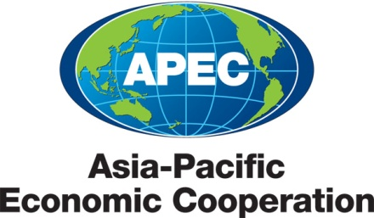
__________________________________________________________________________________________
2011/SOM1/EWG/EGEEC/031
Agenda: D3 5-2

38th Expert Group on Energy Efficiency and Conservation Meeting and Workshop

Submitted by: Korea

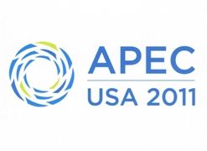 | 37th Expert Group on Energy Efficiency and Conservation Meeting  Washington, D.C., United States  28 February - 2 March 2011

38th APEC EGEE&C meeting & Workshop
Seoul, Korea
7-9 November 2011
(Alternative schedule – Not final – as tabled at EGEE&C 37 on 2 March 2011)

1 day  (7 November 2011) | 2 day  (8 November 2011) | 3 day  (9 November 2011)
Workshops or project meetings  related APEC EGEE&C | 38th APEC EGEE&C meeting | 38th APEC EGEE&C meeting
Workshop 1 | Welcome Address by Ministry of Knowledge Economy | APEC EGEE&C meeting
Workshop 1 | APEC EGEE&C meeting  (Participants of workshop can attend as observers) | APEC EGEE&C meeting
Lunch
Workshop 2 | Site Tour (Samsung Electronic)  (for all participants of APEC EGEE&C and Workshop) | APEC EGEE&C meeting
Welcome Reception hosted by KEMCO
(for all participants of APEC EGEE&C and Workshop)

