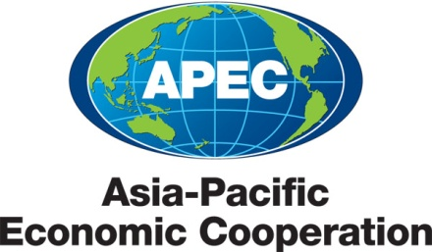
___________________________________________________________________________
2011/SOM1/EWG/EGEEC/024
Agenda: D2 6

APEC Efficient Building Envelope Stakeholders Meeting and Workshop

Submitted by: United States

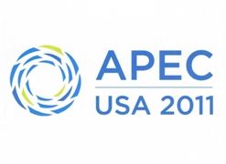 | 37th Expert Group on Energy Efficiency and Conservation Meeting  Washington, D.C., United States  28 February - 2 March 2011

APEC SELF-FUNDED PROJECT INFORMATION

Project number:  (To be filled in by Secretariat: ) | Date received by Secretariat:
Name of Committee/Working Group:
APEC Energy Working Group/Expert Group on Energy Efficiency and Conservation
Title of Project:
APEC Efficient Building Envelope Stakeholders Meeting and Workshop
Proposing APEC Economy: United States, Thailand
Co-sponsoring APEC Economy(ies): Malaysia (TBC), Indonesia (TBC), Vietnam (TBC), Chinese Taipei (TBC), New Zealand (TBC)
Date Approved by Working Group:
Project Overseer: Name, Title and Organization (M/F)
Dr. Twarath Sutabutr (M), Deputy Director General, Department of Alternative Energy Development and Efficiency
Mr. Marc LaFrance (M) US Department of Energy, Buildings Technology Program, Representative to the APEC EGEE&C
Postal address:  Mr. Marc LaFrance Dr. Twarath Satubutr  Office of Energy Efficiency and Department of Alternative  Renewable Energy Energy Development and  1000 Independence Ave SW Efficiency  Washington, DC 20585 17 Rama 1 Road  USA Patumwan, Bangkok  Thailand 10330 |  |  | Tel: (LaFrance) +1 202 586-9142 marc.lafrance@ee.doe.gov  (Satabutr) +662-226-3969  twarath@dede.go.th
Total cost of self-funding in US $ 20,000
Type of Project: X Seminar/symposium Short-term training course Survey or analysis and research

Database/website Workshop Other (pls specify)

Project start date: March 1, 2011 |  | Project end date: July 29, 2011
Brief description of Project : its purpose and the principal activities (including when and where) :
The purpose of this project is to support an efficient buildings envelope workshop and stakeholders meeting. The workshop and meeting will take place in Bangkok, Thailand, June 3-4, 2011. The workshop will bring together the range of public, private and academic sector stakeholders who are involved in developing an advanced building material infrastructure in the APEC region. Key decision makes from APEC economies will be invited to participate and provide their input and observations during the workshop. The workshop will include sessions on policy, technology, component rating, Infrastructure needs and building code implementation. Accurate, and reliable performance data are essential to promoting trade in energy-efficient building materials – such as insulation and energy-efficient roofs and windows. An accurate labeling program helps in implementing of codes and provides verifiable compliance. This workshop will support the establishment of a buildings materials testing and rating center to provide such data so that consumers and businesses will feel confident in buying energy-efficient building components from any APEC economy thus removing trade barriers. A major economic benefit will be that the center will help spur global investment in local manufacturing plants. Host economies will create local manufacturing jobs, and investing economies will have raw material, supplies and equipment order demand creating jobs in their home economy. The overall net effect will be clean energy development that otherwise would not have occurred. This fundamental infrastructure and related capacity building activity, is a prerequisite to effective voluntary and mandatory building policy adoption. Successful establishment of one Regional Energy Center will serve as a template to be replicate in other APEC economies.

This project directly supports the Energy Smart Communities (ESCI) which was jointly announced by Japan and the United States at the APEC Leaders meeting in November 2010. Specifically, this project is a major activity of the Smart Buildings-Materials Testing and Rating Centers (SB-2) activity. This project also builds upon the recently completed APEC Cooperative Energy Efficiency Design for Sustainability (CEEDS) –Phase 2 “Building Energy Codes and Labeling” project.
Signature of Project Overseer:
(Separate written confirmation acceptable for email submission) Date: February 22, 2011
Signature of Committee Chair/WG Lead Shepherd: (Not applicable to Progress Report and Evaluation Report)

(Separate written confirmation acceptable for email submission) Date:

